Kol Simcha Torah Gazette
For parshas vayishlach 5786
Vol 10 Issue 9 (Whole #475) 16 Kislev 5786/ December 6, 2025
Printed L’illuy nishmas Nechama bas R’ Noach, a”h
For a free subscription, please forward your request to keren18@juno.com
Past emails can be found on the website ShabbosStories.com under Brooklyn Torah Gazette
IDF Chief of Staff Attends
Wedding of Chosson He Saved as a Baby 22 Years Ago

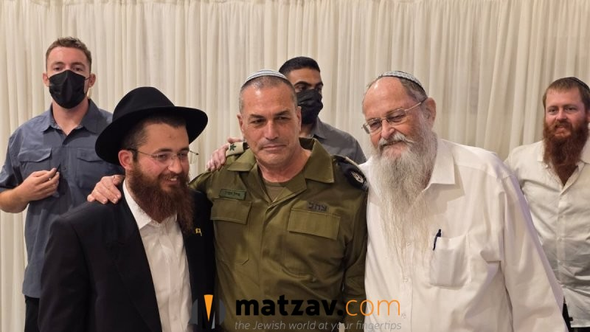

IDF Chief of Staff Eyal Zamir made a deeply personal appearance last night at a wedding in Kfar Chabad — the wedding of a young man whose life he saved as an infant more than two decades ago.
Zamir attended the wedding of Menachem Kirshenzhaft, a resident of the village. Twenty-two years earlier, during Zamir’s tenure as commander of the IDF’s 7th Armored Brigade, he thwarted a terror attack and eliminated the gunman, an encounter that saved the life of baby Menachem and his family.
The original attack occurred on October 24, 2003. The family of Rabbi Yigal Kirshenzhaft, a Chabad shliach, was driving near the community of Neve Dekalim when, at around 9:30 p.m., a terrorist opened fire on their vehicle from the side of the road.
Rabbi Kirshenzhaft later described the frightening moments in an interview with Arutz Sheva. The car was carrying his family and several hitchhikers when suddenly, “about a hundred meters after entering the Gush, gunfire erupted toward the vehicle from the shoulder of the road. We heard the shots and bullets started flying inside the car. The windows shattered and I yelled to my wife,” he recalled.

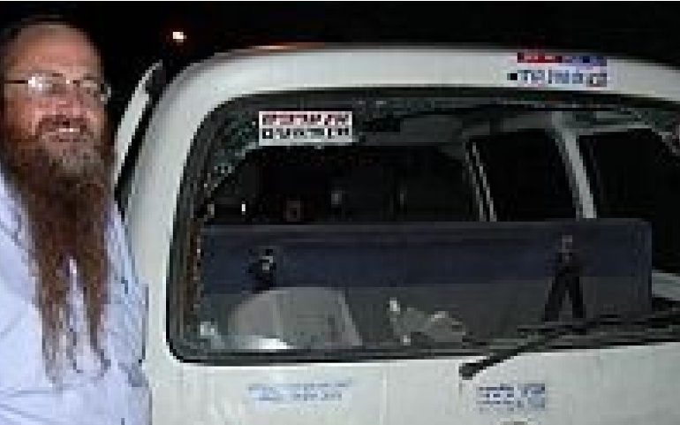
Rabbi Yigal Kirshenzhaft stamding next to his shot-out car 22 years ago.

The family continued driving for another hundred meters as the barrage continued. The rabbi’s wife was lightly injured, as were three of their children. Their one-year-old son was struck lightly by shrapnel. “The entire baby seat next to the window that shattered was filled with fragments,” the rabbi said at the time.
Ynet reported that Zamir raced to the scene in a military jeep with additional soldiers, located the terrorist hiding behind a bush, and fatally shot him. Since that night, Zamir has remained in contact with the Kirshenzhaft family.
At the wedding, Zamir told the family emotionally: “I’ve had many encounters with terrorists, but this was a miracle from Heaven. The entire vehicle was riddled with bullets while the whole family — including the baby who is now the groom — was inside, and no one was hurt. So that today we can stand here and celebrate Menachem’s wedding.”

Reprinted from the current website of Matzav.com

Rav Avigdor Miller on
Should People Cut Down
On the Size of Simchos?

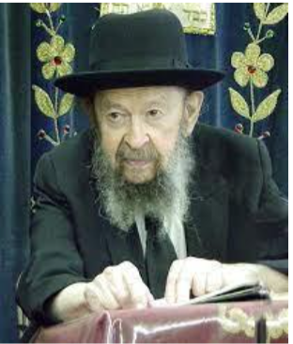

I’ll say it like this. Should people cut down on the cost of simchos? Yes. But the size of simchos, not. So, you should rejoice as much as possible. But you don’t have to hire any waiters in your house. You don’t have to hire halls. You can have many happy occasions without spending too much money.
And that’s a very important matter. Because people are wasting money. I’ll give an example. There’s a couple that wants to make a bar mitzvah in Eretz Yisroel. Now it costs a lot of money to travel to Eretz Yisroel. They say it will cost more if you make it here. So, make it small here and think how much a trip would cost you and send the money there to the yeshivos. It will be a very big merit for you.
There was a girl who lost her father. So, she wanted to go to Eretz Yisroel to visit her father’s grave. I didn’t agree. Stay here and send all the money to charity, to poor talmidei chachamim in Eretz Yisroel for your father’s merit. And your father will appreciate it much more than when you come and stand near his stone.
There are many ways that people can accomplish great things by taking the money they would have wasted and giving it for a righteous purpose; some bigger achievement than squandering it on waiters and on halls and traveling and on things that are not a zechus.

Reprinted from a recent email of Torah Avigdor based on a lecture delivered by Rav Miller on November 22, 1984.

Learning from Jacob that We Can Only Be at Home with
The Coming of the Redemption
From the Teachings of the Lubavitcher Rebbe
Rabbi Menachem Mendel Schneerson, Zt”l
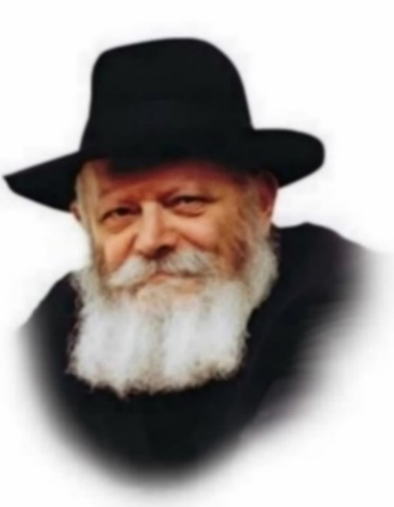
This week's Torah portion, Vayishlach, begins, "And Jacob sent angels before him to greet Esau, his brother." Jacob entrusted the angels with a message: "Im Lavan garti - I have sojourned with Laban." In these words, Jacob summed up the approach he had taken toward Laban throughout his years in Charan: "garti - I have sojourned," i.e., I was only a temporary visitor and never fully at ease.
To Jacob, the mundane affairs of this world were extraneous, removed from his true self and concerns. In Laban's household Jacob was like a ger - a stranger who was only passing through. His interest did not lie in the pursuit of wealth or material riches. Rather, Jacob's true "home" was in the realm of the soul, in Torah study and the observance of mitzvot (commandments). Jacob only felt himself at home, truly at ease and comfortable, when he was involved in the service of G-d.

The Torah states, "He built himself a house, and for his cattle he made booths." For "himself," his true self, Jacob built a "house" - a permanent dwelling. For his "cattle," his material possessions, Jacob built booths - assigning them only marginal importance, like a suka that is designed only for temporary residence.
In this light, we may better understand the explanation of Rashi, the foremost Torah commentator, on the verse "I have sojourned with Laban": "And I have observed the 613 commandments."

In Hebrew letters the number 613 is written taf, reish, yud gimmel - the same letters that form the word "garti" - sojourned. Jacob was informing Esau that despite his extended stay in Laban's household he managed to keep all of the Torah's mitzvot. How? By relating to the physical world and to Laban as being only temporal and transient.

The Maggid of Mezeritch used to say: "At home, it is different." A person's home is his castle; a home must contain all the amenities of life. When a person travels, however, it is not so important if his temporary dwelling is furnished beautifully, for the time spent there is only minimal.

The Jewish people in exile are only "on the road." We are not yet in our true home; rather, we are more like strangers on a temporary visit to a foreign land. Our entire experience in exile is expressed in Jacob's message to Esau: "garti - I am only a sojourner."
The road we are on is the road to the Final Redemption, which, for the Jew, represents true life. In the Days of Moshiach, we will finally be at "home," in our permanent dwelling, engaged in our real task of serving G-d. Indeed, by relating to the physical world and its affairs with this in mind we hasten the Redemption, may it happen immediately.

Reprinted from the Parashat Vayishlach 5763/2002 edition of L’Chaim, a publication of the Lubavitch Youth Organization. Adapted from the works of the Lubavitcher Rebbe.
Thoughts that Count
for Our Parsha

When my brother Esau meets you, he will ask: To whom do you belong? Where are you going?... (Gen. 32:18)
Esau's question is remarkably similar to the Mishna in Avot: "Reflect on three things...know from where you came, where you are going, and before whom you are destined to give a future account and reckoning." Why would the evil Esau suddenly adopt the pious tone of the Mishna? Rather, this question - "Where are you going?"- may be asked by both the Good and the Evil Inclinations. When asked by the Good Inclination, it prevents the person from committing a sin. The Evil Inclination, however, poses the same question in its attempt to bring the individual to despair. In such a case, one must remember that the mere fact that one is a Jew causes unlimited joy and appreciation Above. (Chidushei Harim)

G-d has been kind to me and I have all (Gen. 33:11)
A fundamental characteristic of the Jew is that he is always content with his lot in life. Whatever he is given by G-d is exactly what he needs, no more and no less. This is why Jacob said, "I have all," whereas Esau declared, "I have enough."
(Chasidic Sages)

I am not worthy of all the kindness and faith that You have shown to Your servant (Gen. 32:11)
And what is the greatest kindness of all? That You have made me Your servant! (Torat Avot)

The other band which is left may then escape (Gen. 32:9)
Approaching his brother Esau, Jacob divided his camp into three groups, each of which was for a distinct purpose: to appease Esau with gifts, to pray for G-d's help, and to prepare for war should it become inevitable. This parallels the commandment in the Shema in which we are enjoined to love G-d "with all your heart" (prayer); "with all your soul" (war); "and with all your might" (possessions and wealth). (Sefat Emet)

Reprinted from the Parashat Vayishlach 5763/2002 edition of L’Chaim,
Shot Protecting His
Shul from a Terrorist
By Yehudis Litvak

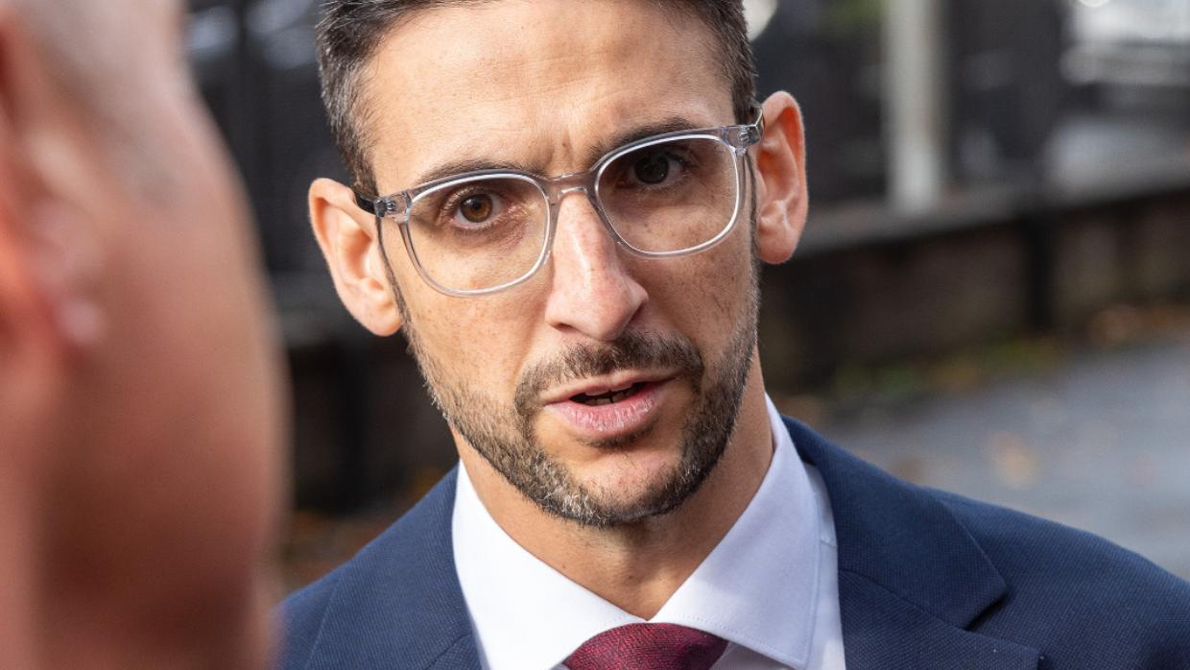

On Yom Kippur morning, terror hit a Manchester synagogue. Yoni Finlay faced the terrorist, fighting to keep the attacker out, and was shot in the chaos.
On Yom Kippur morning in Manchester, Yoni Finlay, 39, came to the Heaton Park Hebrew Congregation in Manchester, U.K. ready to lead prayers. Within moments, a terrorist attacked the synagogue, and Yoni was pulled into a fight to protect his congregation. When police rushed in, shots rang out—and Yoni was hit. What should have been a day of holiness became a face-to-face encounter with evil.
Around 9:30 that morning, Yoni recalls, “I'm waiting, and trying to make sure that I remember the tunes.” Then he heard a loud bang. “That's when we first realized something was wrong. We kind of all looked at each other, what on earth was that?”
The bang came from the terrorist’s car ramming into the synagogue wall in an attempt to get through the gates. At the time, all he saw was Alan Levy, one of the people who welcomes people as they come into the shul, running in, shouting, “Get the doors closed!”
Yoni relates, “I didn't know this at the time, but Adrian Daulby, who, unfortunately, didn't survive, was closest to the door on the left-hand side. He quickly got both doors closed. Then we went out into the foyer because there was something going on, and we didn't know what.”
In the foyer, “the first thing I saw was the security guard, lying on the floor in front of the car,” says Yoni. “Then I saw Andrew Franks, absolutely covered in blood. I didn’t know at the time that he’d been stabbed.” Thankfully, Andrew survived.

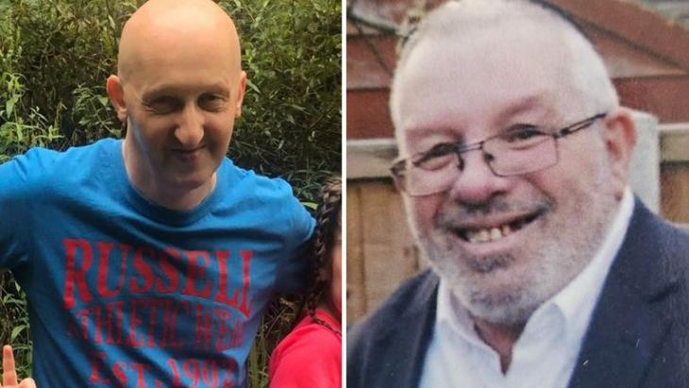(L-R) Adrian Daulby, Hy”d and Melvin Cravitz, Hy’d

Yoni’s father, a doctor, came out to the foyer to administer first aid to Andrew. A consulting geriatrician, he later shared that he was not trained for such a situation.
At that point, the terrorist got out of the car and was trying to break into the synagogue. Yoni recalls, “Just on instinct, people were holding the doors closed. I joined in with that. There must have been 7 or 8 of us on the doors.” Rabbi Daniel Walker, the congregation’s spiritual leader, was one of them. Meanwhile, the terrorist “was doing his best to pull the doors open, because they opened outwards.”
As the terrorist continued to try breaking through doors and windows, Yoni and others “were going from door to door to stop him from coming in. He was running up and down the steps. At one point, he was throwing stuff at the windows to try and get in. He was using his knife to try and shatter the glass, but thank God, he couldn't get in.
“We were in the presence of evil. I've never, ever felt evil radiating off somebody in the way that it did that morning.”
At the time, the men did not think about the danger they were in. Yoni says, “I did notice that he had a very large knife. And he had a belt around his waist that looked like some sort of bomb. But the very weird thing is that you kind of forgot about that. We were just concentrating on keeping the doors closed and making sure he didn't get in.”
What felt like a long time was, Yoni later learned, only seven minutes—but to them it felt like an eternity as they clung to the doors and waited for police to arrive.

Getting Shot
When the armed police finally arrived, the terrorist “came down the steps towards them quite aggressively, and they were shouting at him. They probably saw the bomb, and that's when they shot him. He got back up again, somehow. They shot him again, and that's when the bullet went into me.”
Yoni was shot by a stray police bullet.
“I knew straight away I'd been shot but it didn't hurt. It just feels like someone's punched you very, very hard. But then you're struggling to breathe. I didn't know at the time that my left lung had collapsed. So I'm struggling to breathe, I sort of had my hand over where the bullet had gone in. My thought was, I didn't want to die here.”
Other congregants immediately rushed to help. Yoni remained conscious throughout the ordeal. “People were really good. Somebody lay down next to me, kept talking to me. Somebody gave me some water. They were making sure I was okay until the paramedics could get in. They couldn't get in until the area was clear. So, the police had to come in first, clear the whole area.”
Somebody alerted Dr. Finlay, Yoni’s father. He rushed over, but he felt completely unprepared and helpless. Nothing prepares a father for treating his own seriously wounded child.
When Yoni was finally taken to a hospital by an ambulance “My parents knew I was in hospital being looked after, but for hours they didn't know where I was,” Yoni says. It was an excruciatingly difficult day for them.
In the ER, Yoni was taken for a CT scan. “I'm actually terrified of operations,” He laughs. “It’s one of my biggest fears. I think I tried to convince myself I'd be fine, I just needed a couple of days’ bed rest.”
While waiting, Yoni gave a statement to the police. Then the doctor rushed in with the results of the CT scans. “He said, yeah, we're going to need to operate, sign this. I was taken into the operating theater, and next thing I knew, I was waking up.”
The surgery took over four hours. By the time Yoni woke up, his parents were already in the hospital, at his side. They remain a pillar of support throughout his recovery.

The Victims
Yoni didn’t know that at the time that two of the congregants, Adrian Daulby and Melvin Cravitz, lost their lives in the attack. Melvin was stabbed to death by the terrorist outside the synagogue. Adrian was one of the men holding the synagogue doors closed. He was also shot by a stray police bullet.
Both men were beloved members of the community and are very much missed. Yoni says, “Adrian and Melvin are the type of people that our synagogue is built on. Often, Adrian was the first person I saw when I came into the synagogue, and always with a smile. Always, ‘Hello, how are you? Nice to see you.’ And he was there every Shabbat, in his seat, which I think his father and his grandfather had sat in before him.
“And Melvin's the same, very devoted to his family, very friendly, warm, and welcoming. It affected a huge amount of people, what happened.”
For Yoni, it is especially difficult because both Adrian and Melvin used to sit behind him in the synagogue. “And now, I turn around, and there are two empty seats where there shouldn't be.”

Impact on Family and Community
The whole community has come together in mourning the victims and supporting each other, especially those directly affected.
Yoni’s parents, he says, “are strong people, but an experience like this, it has to affect you. They've been absolutely fantastic, really doing everything that they can for me whilst trying to manage their own trauma.”
Yoni’s four children, ages 16 to 9, are also still processing their trauma. Thankfully, they were not yet in the synagogue at the time of the attack. Yoni says it was a miracle that the attack took place so early in the morning. Two hours later, the synagogue would have been full of people, including children.
“I'm incredibly proud of how they've reacted to it,” Yoni says about his children. “My 16-year-old son gave an interview to one of the media stations on the day after, where he spoke about what had happened, and he said some very nice things about me.”
Another miracle, says Yoni, is that Rabbi Walker was not injured or worse. He had been one of the men going from door to door and holding them closed, as well as administering first aid to the wounded. “He’s held the synagogue together, and he’s been absolutely fantastic.”
Rabbi Walker has been guiding his congregants through the aftermath of the attack, providing encouragement and support as they mourn their losses and carry on.
On Yom Kippur itself, says Yoni, Rabbi Walker “was a pillar of strength. He made a decision that no matter what happened, we're going to carry on. We're not going to miss prayer services.” All the services of Yom Kippur took place that day, first outside, in the street, then at the police station where the congregants were taken, and later, at a local community center. The next morning, the congregation prayed at the rabbi’s house. Then other organizations offered their space, until the synagogue building was reopened for Simchat Torah.
“There wasn’t a prayer missed,” says Yoni. “The rabbi said that we were not going to let the terrorist win. He wanted to stop our prayers, and we weren’t going to let that happen.”

Fighting Darkness with Light
Yoni says, “The Jewish people have this immense power to bring light into the world.” The terrorist embodied “real darkness. He wanted to die, and the only reason he wanted to die is because he hated Jews. He wanted to kill as many Jews as he could. So we have to combat that.”
Yoni urges all Jews around the globe to be the bearers of light through acts of kindness. “It doesn't take a lot,” he says. “Say hello to somebody. Smile. Ask somebody how they are. It doesn't have to be big things, but you can bring that light into somebody else's world.”
“There's so much good in this world,” Yoni says. He witnessed the good in people who “ran towards danger that day. I wasn’t alone in that, just trying to protect the people in the synagogue. There's so much darkness, there's so much hate in this world, but actually we have that power to bring light. Everybody, no matter who you are, has an ability to make a difference. It doesn't take a lot to put a smile on someone's face, to make somebody feel good, and we have no idea what impact this has on people.”

The Outpouring of Kindness
Yoni stayed in the hospital for ten days. He is tremendously grateful to the doctors and nurses. “I had nothing but absolutely wonderful care and support,” he says. “I was incredibly well looked after.”
Yoni says he was overwhelmed by the outpouring of support he and his children received from the community.
“The unity that the Jewish community displayed is remarkable,” says Yoni. He recalls that the police later commented on how impressed they were with the whole Jewish community. “People bought food out to them, people made sure that they were warm, they had what they needed. Because it's how we respond. We don't respond with violence, we don't respond with revenge. That's not who we are.”
Within days of the attack, the synagogue received over 2,000 messages from all over the world, from both Jews and non-Jews, expressing their horror at the attack, condolences on the lives lost, and well wishes for the wounded.

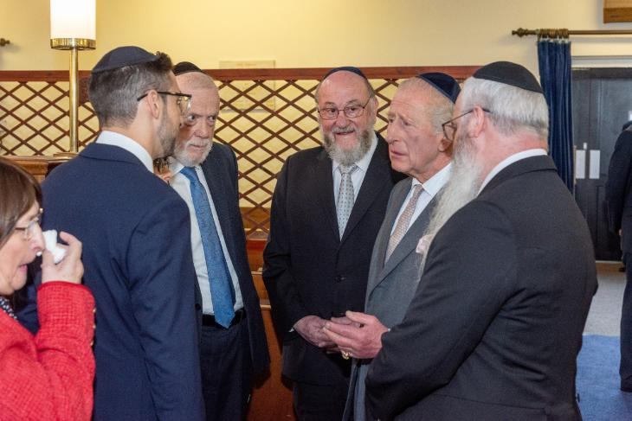Yoni, left, with King Charles and Chief Rabbi Ephraim Mervis

Two weeks after the terrorist attack, King Charles visited the synagogue and met with the congregants. He offered condolences and expressed his solidarity with the community. Yoni says that the king’s visit was very important to the community because it “showed us that we're not alone.”

Carrying On
After Yoni was discharged from the hospital, he was nervous about going back to the synagogue and being reminded of the trauma. “But the welcome I got was so warm,” he says. “There wasn't really time to think about what happened. I was never on my own. I sat, and people came over to talk to me, and at no time was I sitting there by myself. People were making sure I was okay.”
Yoni still struggles with survivor’s guilt. “I'm not sure if it's the same bullet that went into me that also went into Adrian, but certainly it was this close… and Adrian isn't here, and Melvin isn't here, and that's really difficult for me to cope with.”

At the same time, Yoni is grateful to G-d for the miracle of his survival. Physically, he is on the mend. “Thank G-d, I've had the good news that I'm allowed to go running again,” he says. “There's still bits of pain, but I'm walking, I'm going out and doing things.”

He sees his experience as a lesson that “ultimately, we don't know what tomorrow brings” and advises others not to put off for tomorrow anything that is important to them.

On a practical level, the synagogue is increasing its security measures. The community is concerned about the rise of antisemitism in the U.K. over the past two years. Yoni says, “There's been so much hate towards the Jews in this country, and it's fueled by the media.” What happened on Yom Kippur, says Yoni, “was a shock but not a surprise.” The terrorist did not wake up that morning and decide to kill Jews. The hatred had been continuously fed to him by the media.

Yoni explains that these seemingly small and insignificant messages are the flip side of small acts of kindness making a difference. Small acts of hate have a major effect on the world. “People really have to think about the consequences of what they say and what gets put out there, because ultimately, it has an impact,” says Yoni.

Overall, Yoni believes that “there's far more good in this world than there is evil. It comes down to looking at the light versus the darkness, hope versus hate. Doing things for other people that show you care -- I fundamentally believe that that overcomes hatred. We have to put that good back into the world.”

Reprinted from the current website of aish.com

The One Sin Hashem
Will Never Overlook

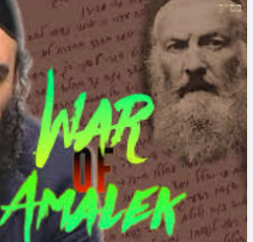

And Yaakov was left alone and a man wrestled with him until the break of dawn. (32:25) Who was this man? Rashi says he was the ministering angel of Esov. Chazal say that he is like Amalak. In each and every generation there is a physical
Amalak fighting Benai Yisroel as well as a spiritual Amalak tempting Benai Yisroel. So where was this Amalak during the times of Avraham and Yitzchak? How come we don’t find any reference to him before this?
Chazal tell us that sometimes Hashem will look away at the sins of idol worship, illicit relations and murder but Hashem will not look away at the sin of not learning Torah.
Why? When two nations go to battle anything can happen. Even if one day it seems one nation is winning, the other nation can rebound and win the next day. The tide of battle can always turn - with one exception. If one nation destroys the armor, tanks, planes and ammunition of the enemy, then the war is over.
The second nation has no chance to recover. The armor and ammunition of Benai Yisroel is Torah. No matter what Benai Yisroel does wrong, Torah gives the ability to rebound. But if Benai Yisroel abandon Torah, there is no chance.
Therefore, Hashem will not look away at the sin of not learning Torah. Avraham was the symbol of kindness - the Angel of Esov didn’t bother fighting. Yitzchak was the symbol of service to Hashem - the Angel of Esov didn’t bother fighting. Yaakov was the symbol of Torah - the Angel of Esov attacked where it matters. (Rabbi Elchonon Wasserman)

Reprinted from the Parshas Vayislach 5786 email of R’ Yedidye Hirtenfeld’s whY I Matter parsha sheet for the Young Israel of Midwood in Brooklyn, NY.

